Request for Applications (RFA) Announcement:

Preventing and Reducing Opioid Used Disorder (PROUD) Program

An informational webinar on this opportunity will be hosted on August 22, 2025, 1 p.m. PDT
Questions to be submitted via email on or before August 25, 2025, 3 p.m. PDT to PROUD@veterans.nv.gov with PROUD RFA in the subject line of the email.
Responses to questions will be posted on or before August 27, 2025, 3 p.m. PDT, at the following link: PROUD Funding Opportunities
Letter of Intent to Apply: On or before August 29, 2025, 3 p.m.
DEADLINE FOR APPLICATION SUBMISSION: Friday September 19, 2025, 3 p.m. PDT
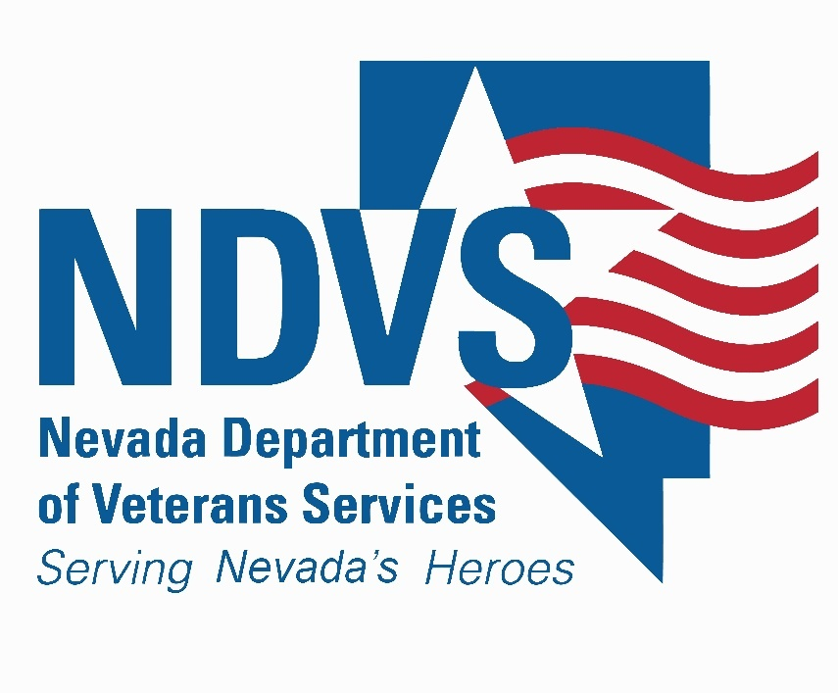
For additional information, please contact: PROUD program staff at PROUD@veterans.nv.gov

NDVS Request for Application Summary

The Nevada Department of Veterans Services (NDVS) is pleased to announce the availability of funding through the Preventing and Reducing Opioid Use Disorder (PROUD) Program. This funding opportunity is part of the Fund for Resilient Nevada’s (FRN) response to the urgent opioid crisis plaguing the United Sates. Through this funding, PROUD aims to help Nevada’s veteran communities.

The project period will run from November 1st 2025 through June 30th 2026, with the opportunity to renew for an additional year running July 1st 2026 through June 30th 2027. Budgets and an updated Scope of Work will need to be resubmitted annually for each year of the project.

- Year 1: November 1st 2025 – June 30th 2026
- Year 2: July 1st 2026 – June 30th 2027

Background:

The PROUD Program for veterans is an initiative led by NDVS. PROUD aims to address the opioid crisis by providing funding to support prevention, treatment, recovery, and harm reduction efforts related to opioid use disorder (OUD) and opioid-related overdoses for Nevada veterans and their families.

This opportunity launched in response to the growing opioid epidemic, which has had devastating effects on communities across the United States. NDVS seeks to expand access to evidence-based treatment, improve the quality of care for individuals with OUD and enhance efforts to prevent opioid misuse and overdose.

NDVS is requesting applications from community stakeholders to support the state’s efforts to combat the opioid epidemic and save lives affected by OUD.

Funding Priorities:

Funding priorities will be guided by the recommendations outlined by FRN as part of State Opioid Response, emphasizing infrastructure and framework development to support effective program implementation. More information on Nevada’s State Needs Assessment and State Plan can be found here. Health equity considerations and adherence to best practices and evidence-based programs are fundamental to achieving sustainable and equitable outcomes for Nevada veterans and their families.

Priority Populations:
- Veterans
- Immediate family members of veterans*
*For this program immediate family members defined as parents, spouse, and children.
Estimated Number of Awards: The number and dollar amount of grant awards will depend on
the quality and number of applications. The statewide plan may also allocate money to statewide
projects through direct budget allocations.

Estimated Dollars Available: $300,000
Program Activities:

Applicants of the PROUD program must include at least one of the two primary activities below as the focus of their program:

Increasing Use of Medications to Treat OUD:
Enhance utilization of evidence-based medications for the treatment of OUD through Opioid Treatment Programs, Office-Based Addiction Treatment Programs, Federally Qualified Health Centers, community health centers, and other related healthcare and community-based service providers. (Resource*: SAMHSA TIP 63: Medications for Opioid Use Disorder)

Broaden Access to Behavioral Health Treatment
Enhance utilization of evidence-based therapies for the treatment of OUD through Opioid Treatment Programs, Office-Based Addiction Treatment Programs, Federally Qualified Health Centers, community health centers, and other related healthcare and community-based service providers. Connect veterans and their families to outpatient mental health/therapy for treatment services. (Resource*: SAMHSA Evidence-Based Practices Resource Center)

Secondary Activities:

Applicants are encouraged to include activities from the following list in their application:

Broadening Access to Naloxone:
Expand access to naloxone, a lifesaving medication for opioid overdose reversal, and other overdose prevention strategies specifically targeted at individuals with OUD. (Resource*: SAMHSA Opioid Overdose Prevention Toolkit)

Providing Culturally Competent Care:
Increase culturally appropriate outreach and education efforts for at-risk populations, including those affected by OUD. This may include vulnerable age groups, sexual orientations, cultures, tribes, genders, underserved rural and historically under-resourced populations. (Resource*: Evidence-Based and Culturally Relevant Behavioral Health Interventions in Practice: Strategies and Lessons Learned from NNEDLearn (2011-2020) (samhsa.gov)

Bolstering Peer Recovery Support Specialist Work:
Expand the role of peer recovery support specialists in various settings, including healthcare, community, and employment services. Enhance training to include competencies related to OUD. Ensure their involvement in all aspects of the recovery process, from initial treatment to long-term follow-up and policy development. (Resource*: SAMHSA’s TIP 64: Incorporating Peer Support Into Substance Use Disorder Treatment Services)

Supporting Rural Community Initiatives:
Support initiatives to address and include the unique challenges in rural communities, leveraging telehealth services and transportation assistance to underserved areas, with a focus on OUD. (Resource*: CDC’s Public Health Strategies for Opioid Overdoses Policy Brief)
Enriching Prevention Strategies:
Strengthen prevention efforts through evidence-based interventions targeting opioid use, focusing on at-risk populations. (Resource*: New York State Office of Addiction Services and Supports’ Evidence-based Prevention Programs)

Expanding of Harm Reduction Programs:
Increase access to harm reduction services to reduce the spread of infectious diseases and overdose deaths, with a focus on individuals with OUD. (Resource*: SAMHSA Harm Reduction Framework | SAMHSA)

Increasing Public Awareness Campaigns:
Increase public awareness campaigns to target high-risk areas and populations identified by publicly available overdose data sources, including awareness on the dangers of opioid use. (Resource*: University of Nevada Reno’s School of Public Health Nevada Opioid Communication Assessment)

*The resources listed above are supplemental materials meant to serve as a tool for applicants and are not exhaustive guides for what is and is not allowable.

Unallowable Expenses and Activities**

When applying for NDVS funding, it is important to ensure that the proposed budget and activities align with FRN’s guidelines for allowable expenses. FRN is established in Nevada Revised Statutes (NRS) 433.712 through 433.744 and funding is guided by the required Nevada Opioid Needs Assessment and Statewide Plan 2022. PROUD Program recipients will follow these guidelines outlined by FRN. The following is a list of unallowable expenses and activities that cannot be funded under this grant program:

1. Supplanting Existing Funds
Federal funds must supplement, not replace existing state or local funds. Using FRN funds to replace state or local funds for ongoing activities that would otherwise be funded through those sources is strictly prohibited.

2. Lobbying and Advocacy
Grant funds may not be used for lobbying activities designed to influence legislation, appropriations, regulations, administrative actions, or Executive Orders.

3. Construction and Major Capital Improvements
Funds generally cannot be used for construction, renovations, or capital improvements of facilities. This includes the purchase or improvement of land, or the cost of equipment or systems intended to be capitalized.
*If there is any uncertainty regarding what constitutes allowable renovation expenses, please contact the NDVS Team for clarification before submitting your budget.

4. Direct Payments to Recipients of Services
Grant funds cannot be used for direct payments or cash incentives to individuals receiving services.

5. Entertainment, Food, and Beverages
Costs related to entertainment, including social activities, alcohol, and unrelated meals or refreshments, are not allowable. This includes expenses related to food or beverages for meetings or events unless specifically justified and approved by NDVS as necessary to achieve program goals.

6. Expenses Related to Fines and Penalties
Funds may not be used to cover fines, penalties, or legal fees resulting from the violation of, or failure to comply with, federal, state, or local laws and regulations.

7. Reimbursable Services Covered by Other Programs
Services that are reimbursable through other sources such as Medicaid, Medicare, or private insurance cannot be covered by FRN funds. The recipient must ensure that all other payment options have been exhausted before using grant funds. This includes, but is not limited to, clinical treatment services, medications, and other healthcare services that can be billed to Medicaid or any third-party payer. FRN funds are intended to be used to expand access to care, enhance services, and support activities that are not otherwise covered by Medicaid or other insurance programs, regardless of rates of reimbursement.

8. Fundraising Activities
Funds cannot be used for fundraising activities, including the production of promotional materials or events intended to raise additional funds.

9. Goods or Services for Personal Use
Costs for goods or services for personal use by the grantee’s employees are not allowable.

10. Inconsistent with Federal and State Requirements
Any activities or expenses that do not comply with applicable federal, state, and local laws and regulations are unallowable.

11. Debt Retirement
Funds cannot be used for the repayment of debts or the payment of interest or late fees on outstanding debts.

**Note: This list is not exhaustive. If you have any questions regarding allowable and unallowable expenses, please contact the NDVS Team for clarification and guidance.

Requirements for Data Collection and Reporting

As a condition of funding under the Nevada State Fund for Resilient Nevada (FRN) Grant Program, all entities providing treatment and recovery services are required to collect and report on data related to program progress throughout the course of the performance period.

Data Collection Requirements
Entities must use a standardized data collection tool provided by NDVS, which will gather information on NDVS-specified variables and measures at three key points:

Patient Centered:
- Intake: When a client first receives NDVS PROUD-funded services.
- Discharge: Upon a client’s completion or termination of NDVS PROUD-funded services.

Program Monitoring:
- Monthly Progress: Monthly collection of performance data.

The tool used for data collection and reporting is REDCap, which is a secure, web-based application for data collection and management.

Reporting Requirements
- Patient Centered data must be submitted within 48 hours of collection.
- Monthly Progress data must be submitted within 10 days following the end of each month.

Training and Technical Assistance
Upon award, recipients will receive training and technical assistance to effectively implement data collection and reporting. Staff will also be available during the period of the program for technical assistance or training as needed. The program will incorporate monthly check-ins with time dedicated to training and technical assistance.

Eligibility:

FRN funding is designed to support a wide range of entities committed to combating the opioid crisis across the state. To ensure that funded programs are effective and sustainable, the FRN grant is available to various types of organizations that have demonstrated the capacity to deliver impactful services. This includes:

Nevada-Based Government Agencies: County health departments, city governments, and other local government entities may apply for FRN grants to support prevention, treatment, and recovery efforts at the community level. These entities often work closely with healthcare providers, law enforcement, and community-based organizations to implement programs and services.

Community-Based Organizations: Nonprofit organizations, community health centers, substance use treatment providers, tribal entities, and other community-based organizations may apply for FRN funding to expand access to services, provide education and outreach, and support individuals affected by opioid and/or stimulant use disorders.

Healthcare Providers: Hospitals, clinics, and healthcare systems may apply for FRN grants to enhance opioid and stimulant-related services, such as MOUD, overdose prevention, monitoring and management of co-occurring disorders, integrated care and case management and behavioral therapies. These entities play a crucial role in delivering healthcare services and addressing the needs of individuals with opioid use disorder.

Coalitions and Partnerships: Collaborative efforts involving multiple stakeholders, including government agencies, healthcare providers, community organizations, and advocacy groups, may apply for FRN grants to implement comprehensive strategies to address the opioid crisis. These partnerships leverage diverse expertise and resources to maximize impact.

For-Profit Entities: Businesses and organizations operating within the state of Nevada that can demonstrate a commitment to addressing the opioid crisis through harm reduction, treatment, prevention, or recovery services.

Experience Requirement: NDVS requires that each mental health/substance use disorder prevention, treatment, recovery support and/or harm reduction organization must have at least two years of experience providing relevant services as of September 1, 2025. Each applicant for the PROUD program must also possess a site certification for Behavioral Health Certifications for Excellence in Nevada (BHCEN), previously known as SAPTA/SUPTRS.
OR
Ability to provide BHCEN certification within 6 months of receiving award
OR
Provide the level of program accreditation that meets or exceeds BHCEN Certification standards (ex: hospital organization - Joint Commission). Programs that are Commission on Accreditation of Rehabilitation Facilities (CARF)- accredited must still obtain BHCEN certification.

Information on applying for BHCEN can be found here.

This is in alignment with FRN requirements through NRS 458 and NAC 458.

Informational Webinar:

An informational webinar will be held via Microsoft Teams on Friday August 22nd, 2025, at 1:00 PM (PST) to provide an overview of the NDVS application requirements. This webinar will offer potential applicants an opportunity to learn more about the funding process, key application components, and eligibility criteria. Additionally, there will be a Q&A session to address any questions. We encourage all interested applicants to attend this webinar to ensure a thorough understanding of the application process.

Join the meeting now
Meeting ID: 220 442 275 431
Passcode: Kw7Dq2Rm

Dial in by phone
+1 775-321-6111,,959786424# United States, Reno
Find a local number
Phone conference ID: 959 786 424#

Details on how to join the webinar will also be posted to the NDVS webpage: PROUD program.

Letter of Intent and Application Deadlines:

Letter of Intent
Entities interested in applying for funding are asked to submit a short Letter of Intent (LOI) to the PROUD Program by August 29, 2025, 3pm, ahead of submitting the full application. The LOI should include:
- Name of Organization
- Contact Information
- Which area(s) of focus your project addresses: Prevention, Treatment, Recovery, and/or Harm Reduction
- Project Period Dates
- Estimated Funding Request for Year 1 of the Project

Application
Applications must be submitted electronically via email to the PROUD program staff at PROUD@veterans.nv.gov by Friday September 19th 2025 at 3pm.

Please use the Preventing and Reducing Opioid Use Disorder (PROUD) Application, Scope of Work, and Budget templates found on the PROUD Funding Opportunities page.

Late applications are not guaranteed funding during this budget period. However, any submitted application may be considered for inclusion in an application pool for potential funding opportunities later, subject to the availability of funds and the priorities of the program.

Contact Information:

For any questions regarding the application process, please contact program staff at PROUD@veterans.nv.gov

